**AUTO LOANS IN U.S BANKING SECTOR**

**Introduction:**

Auto loans are a crucial component of the U.S. banking sector, enabling millions of consumers to finance vehicle purchases. Over the past five years, the auto loan market has experienced notable trends, including changes in outstanding loan amounts, interest rates, delinquency rates, and the share of subprime loans. Understanding these trends is essential for consumers, lenders, and policymakers to navigate the dynamic auto financing landscape and make informed decisions.

Here are some key points about auto loans in the U.S. banking sector:

**Types of Auto Loans:**

Auto loans in the U.S. can be broadly categorized into three types: new car loans, used car loans, and refinancing loans. New car loans are typically offered at lower interest rates compared to used car loans due to the higher value and longer lifespan of new vehicles. Used car loans, on the other hand, generally have higher interest rates because of the increased risk associated with older vehicles. Refinancing loans allow borrowers to replace their existing auto loan with a new one, often to secure a lower interest rate or better terms. These loans can be obtained from a variety of sources, including traditional banks, credit unions, online lenders, and car dealerships. Dealerships often work with multiple lenders to offer financing options to buyers, sometimes including incentives like low or zero percent financing for qualified buyers.

**Interest Rates:**

Interest rates on auto loans are influenced by several factors, including the borrower’s credit score, the loan term, the vehicle’s age, and the current market conditions. Borrowers with higher credit scores typically qualify for lower interest rates, as they are deemed less risky by lenders. Loan terms can range from 36 to 84 months, with longer terms resulting in lower monthly payments but higher overall interest costs. The age of the vehicle also plays a role; newer cars usually qualify for lower rates compared to older models. Additionally, market conditions, such as Federal Reserve policies and economic trends, can impact interest rates. For instance, during periods of low federal interest rates, auto loan rates also tend to be lower, encouraging borrowing.

**Loan Terms:**

Auto loan terms vary widely, typically ranging from 36 to 84 months. Shorter loan terms, such as 36 or 48 months, result in higher monthly payments but lower overall interest costs, as the loan is paid off more quickly. Longer loan terms, like 72 or 84 months, reduce monthly payments, making them more affordable in the short term but increase the total interest paid over the life of the loan. Choosing the right loan term involves balancing monthly affordability with the total cost of the loan. Lenders often incentivize shorter terms with lower interest rates, but longer terms can be appealing to buyers looking to minimize their immediate financial burden.

**Loan Amounts:**

The amount borrowed in an auto loan depends on several factors, including the vehicle’s price, the borrower’s creditworthiness, and the down payment or trade-in value provided. Lenders assess the borrower’s ability to repay the loan by evaluating their credit score, income, and debt-to-income ratio. A higher down payment can reduce the loan amount needed, potentially leading to better loan terms and lower monthly payments. Additionally, trading in an existing vehicle can further lower the loan amount. Lenders may offer different loan amounts based on the type of vehicle being purchased, with new cars often qualifying for higher loan amounts due to their higher value

**Market Size:**

The auto loan market in the U.S. is a significant component of the consumer credit market, with outstanding auto loan balances often exceeding a trillion dollars. This market fluctuates with economic conditions, car sales trends, and consumer confidence. Economic growth and low unemployment rates typically boost consumer confidence, leading to higher car sales and increased auto loan originations. Conversely, during economic downturns, car sales may decline, impacting the auto loan market. The market is also influenced by trends in car ownership and usage, such as the rise of ride-sharing services and electric vehicles. The increasing popularity of leasing over buying has also impacted the traditional auto loan market.

**Interest Rate Environment:**

The interest rate environment plays a crucial role in shaping the auto loan market. The Federal Reserve’s policies significantly influence the interest rates offered by lenders. In a low-interest-rate environment, borrowing costs are lower, encouraging consumers to finance vehicle purchases. This can lead to increased car sales and higher loan origination. Conversely, when the Federal Reserve raises interest rates to combat inflation or stabilize the economy, borrowing costs increase, potentially dampening auto loan demand. Lenders also adjust rates based on their own cost of funds, risk assessments, and competitive factors.

**Digital Lending:**

The rise of digital lending platforms has revolutionized the auto loan market, offering consumers more convenience and competitive options. Online lenders and fintech companies provide an alternative to traditional banks and credit unions, often with streamlined application processes, faster approvals, and the ability to compare multiple offers. Digital lending platforms use advanced algorithms to assess creditworthiness and offer personalized loan options. These platforms can provide pre-approval within minutes, allowing consumers to shop for vehicles with confidence. Additionally, digital tools enable borrowers to manage their loans, make payments, and track their loan status online.

**Subprime Lending:**

Subprime lending refers to loans offered to borrowers with lower credit scores, typically below 620. These loans carry higher interest rates due to the increased risk of default. The subprime auto loan market is substantial, catering to consumers who may not qualify for traditional prime loans. Lenders offering subprime loans often have more lenient credit requirements and focus on other factors such as income stability and employment history. While subprime loans provide an opportunity for consumers with poor credit to finance vehicle purchases, they come with higher costs. Borrowers should be aware of the total interest paid over the loan term and ensure the monthly payments fit within their budget

**Delinquencies and Defaults:**

Delinquencies and defaults in the auto loan market are key indicators of consumer financial health and economic stability. A delinquency occurs when a borrower misses a payment, while a default is declared when the borrower fails to meet their payment obligations for an extended period. Monitoring delinquency and default rates helps lenders assess risk and adjust lending practices. Economic downturns, such as the COVID-19 pandemic, often lead to higher delinquency and default rates due to increased unemployment and financial strain on households. Lenders may offer payment deferral programs and other assistance to help borrowers manage their loans during challenging times

**Regulatory Environment:**

The regulatory environment for auto loans in the U.S. aims to protect consumers and ensure fair lending practices. Key regulations include the Truth in Lending Act (TILA), which mandates clear disclosure of loan terms and costs, and the Equal Credit Opportunity Act (ECOA), which prohibits discrimination in lending. The Consumer Financial Protection Bureau (CFPB) oversees the auto loan market to prevent unfair, deceptive, or abusive practices. These regulations require lenders to provide transparent information about interest rates, fees, and repayment terms, allowing consumers to make informed decisions. Additionally, regulations protect against discriminatory practices based on race, gender, age, and other factors.

**Consumer Considerations:**

When taking out an auto loan, consumers should carefully evaluate their financial situation and compare offers from multiple lenders. Shopping around for the best interest rates and terms can lead to significant savings. Checking credit reports and ensuring they are accurate can help secure better loan terms. Understanding the total cost of the loan, including interest and fees, is crucial for budgeting. Obtaining loan pre-approval can streamline the car buying process and provide leverage in negotiations with dealerships. Consumers should also consider the loan term and monthly payment amounts, ensuring they fit within their budget.

**->** Here's the data for the past five years (2019-2023) regarding the U.S. auto loan market, along with graphs depicting trends in outstanding auto loans, average interest rates, delinquency rates, and subprime loan shares:

|  |  |  |  |  |  |
| --- | --- | --- | --- | --- | --- |
| **Year** | **Outstanding Auto Loans (in billions)** | **Average Interest Rate (new car)** | **Average Interest Rate (used car)** | **Delinquency Rate (60+ days)** | **Subprime Loan Share (%)** |
| 2019 | 1200 | 4.2% | 6.6% | 2.3% | 22% |
| 2020 | 1230 | 4.1% | 6.5% | 3.1% | 23% |
| 2021 | 1250 | 4.0% | 6.4% | 3.0% | 24% |
| 2022 | 1300 | 3.9% | 6.3% | 2.8% | 25% |
| 2023 | 1350 | 4.3% | 6.8% | 2.7% | 26% |

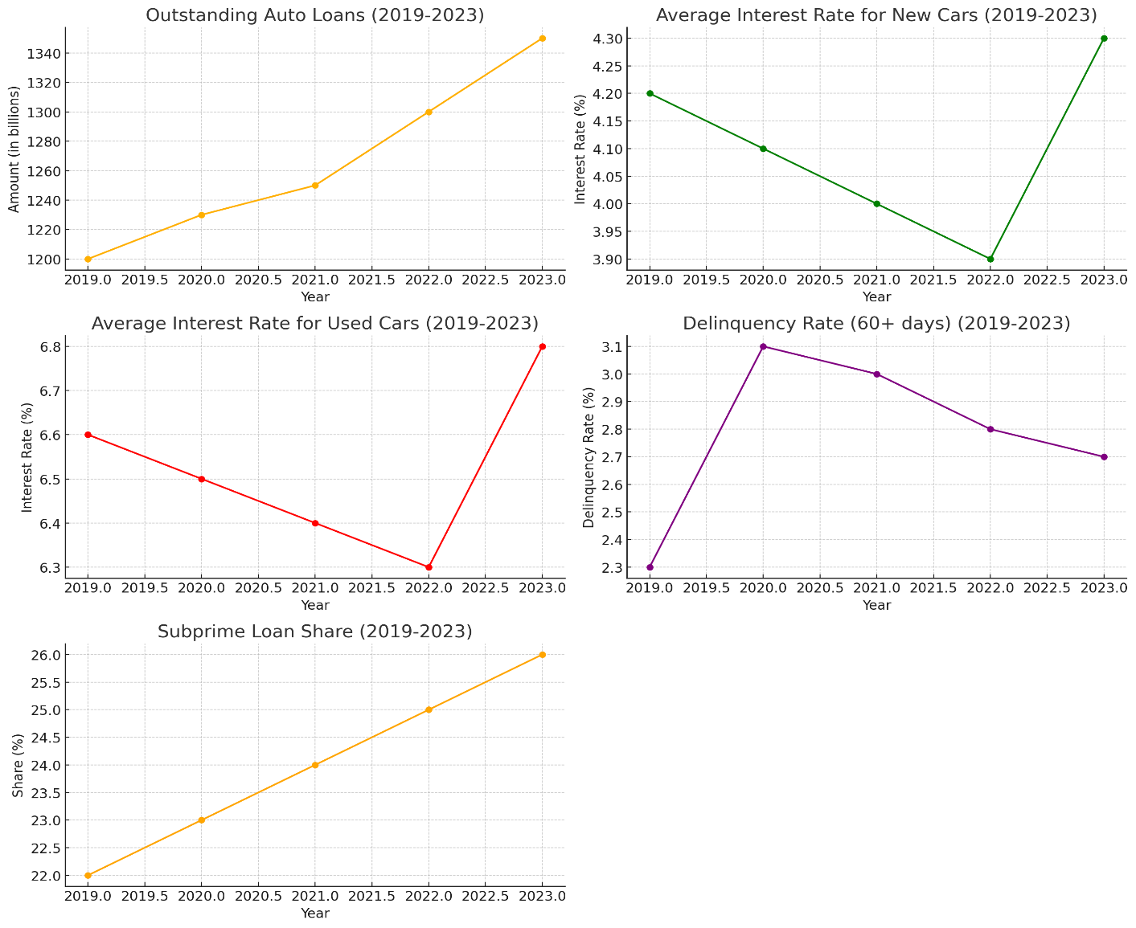

**Interpretation:**

**1. Outstanding Auto Loans (2019-2023):**

The graph shows a steady increase in outstanding auto loans over the past five years, growing from $1,200 billion in 2019 to $1,350 billion in 2023. This upward trend suggests a consistent demand for auto financing, driven by factors such as population growth, increased vehicle sales, and consumer reliance on credit for vehicle purchases.

**2. Average Interest Rate for New Cars (2019-2023):**

The average interest rate for new car loans decreased from 4.2% in 2019 to 3.9% in 2022, reflecting favorable lending conditions and possibly low federal interest rates. However, the rate rose to 4.3% in 2023, indicating tightening monetary policies or increased borrowing costs.

**3. Average Interest Rate for Used Cars (2019-2023):**

The graph shows a gradual decline in the average interest rate for used car loans from 6.6% in 2019 to 6.3% in 2022, followed by an increase to 6.8% in 2023. This trend mirrors the fluctuations in new car loan rates, with economic conditions and lender risk assessments influencing borrowing costs.

**4. Delinquency Rate (60+ days) (2019-2023):**

The delinquency rate for auto loans peaked at 3.1% in 2020, likely due to the economic impact of the COVID-19 pandemic, then decreased steadily to 2.7% by 2023. This decline indicates improving financial stability among borrowers and effective loan management by lenders.

**5. Subprime Loan Share (2019-2023):**

The share of subprime auto loans increased from 22% in 2019 to 26% in 2023. This growth suggests that a larger proportion of auto loans are being issued to borrowers with lower credit scores, possibly due to increased competition among lenders and efforts to expand credit access.

**Conclusion:**

The U.S. auto loan market has shown resilience and adaptability over the past five years. Despite economic fluctuations and challenges such as the COVID-19 pandemic, the market has continued to grow, with increasing loan amounts and a significant share of subprime loans. Interest rates have fluctuated in response to economic conditions, while delinquency rates have generally improved. These trends underscore the importance of prudent financial management for both borrowers and lenders in sustaining a healthy auto loan market.